Lab Manual
Digital Integrated Circuit Design
[ET3288]

Third Year Bachelor of Technology Semester – V

Course Coordinator
Dr. Abhay Chopde

Course Teacher
Minal S. Deshmukh

Technical Assistant
Mr. Nilesh Bhoj

Head of Department
Prof. (Dr.) Medha Wyawahare


Department of Electronics and Telecommunication Engineering
VISHWAKARMA INSTITUTE OF TECHNOLOGY, PUNE
(An Autonomous Institute Affiliated to Savitribai Phule Pune University)
JULY 2026

INDEX
`
Sr.  No | Title | Page  No | Date | Signature | Remark
1 | SPICE modeling of NMOS and PMOS transistor to plot IDS Vs. VDS and IDS Vs. VGS  characteristics. | 3
2 | Write SPICE model for CMOS inverter and perform  transient and DC analysis. | 8
3 | To perform transient and DC  analysis of CMOS Inverter using Cadence Virtuoso. | 11
4 | Design of CMOS Inverter  layout using Cadence Virtuoso | 15
5 | To perform simulation and plot transient response of 2-input NAND Gate. | 18
6 | Design of CMOS 2 Input NAND Layout. | 22

This is to certify that Sudarshan Anil Chaudhari of class TY E&TC, Division G Roll No.
06 have performed the above listed experiments in the Digital IC Design course Laboratory in the Department of Electronics and Telecommunication Engineering at Vishwakarma Institute of Technology, Pune.

Date:

In-Charge Faculty Head of Department

Name: Sudarshan Anil Chaudhari Roll No.: 06
PRN No.:12520111
Division: G

EXPERIMENT NO: 01
TITLE OF EXPERIMENT: SPICE modeling of NMOS and PMOS transistor to plot IDS Vs. VDS and IDS Vs. VGS characteristics.

  - Aim: - Do SPICE modeling of NMOS and PMOS transistor to plot IDS Vs. VDS and IDS Vs. VGS characteristics.
  - Software/Hardware: - Any SPICE tool like Winspice, NGspice etc.
  - SPICE codes: (Copy paste your SPICE code here. Write your name and PRN No. in comments.) (Use L = 90 nm and W = 1 um for both transistors. Use VDD = 1V, VDS,max = VSD,max = 1V, VGS,max = VSG,max = 1V)

    - SPICE code for IDS Vs. VDS Characteristic of NMOS:
      - NMOS IDS vs VDS
.model NMOS NMOS (LEVEL=1 VTO=0.4 KP=200u) VGS G 0 0.5
VDS D 0 0
M1 D G 0 0 NMOS L=90n W=1u
.dc VDS 0 1 0.01
.control run
plot -i(VDS)
.endc
.end

    - SPICE code for IDS Vs. VGS Characteristic of NMOS:
      - NMOS IDS vs VGS
.model NMOS NMOS (LEVEL=1 VTO=0.4 KP=200u VGS G 0 0
VDS D 0 1
M1 D G 0 0 NMOS L=90n W=1u
.dc VGS 0 1 0.01
.control run
plot -i(VDS)
.endc
.end

    - SPICE code for IDS Vs. VDS Characteristic of PMOS:
      - PMOS ISD vs VSD
.model PMOS PMOS (LEVEL=1 VTO=-0.4 KP=200u)
      - VSG = 0.5 V VSG S G 0.5
      - VSD = 0 to 1 V VSD S D 0

      - PMOS: Drain Gate Source Bulk M1 D G S S PMOS L=90n W=1u
.dc VSD 0.001 1 0.01

.control run
plot i(VSD)
.endc
.end

    - SPICE code for IDS Vs. VGS Characteristic of PMOS:
      - PMOS ISD vs VSG
.model PMOS PMOS (LEVEL=1 VTO=-0.4 KP=200u)
      - Source = 1 V VSS S 0 1
      - VSG swept from 0 to 1 V VSG S G 0
      - VSD = 1 V VSD S D 1
      - PMOS: Drain Gate Source Bulk M1 D G S S PMOS L=90n W=1u
.dc VSG 0 1 0.01
.control run
plot -i(VSD)
.endc
.end

  - Simulation result screenshots: (Copy paste simulation result screenshots here.)
- IDS Vs. VDS Characteristic of NMOS for VGS = 0.5V: IDS, max = 11 uA.
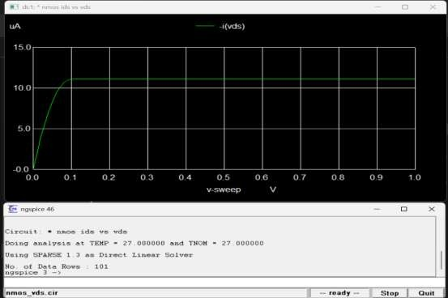

- IDS Vs. VGS Characteristics of NMOS for VDS = 1V: Approx. Vth = 0.4V
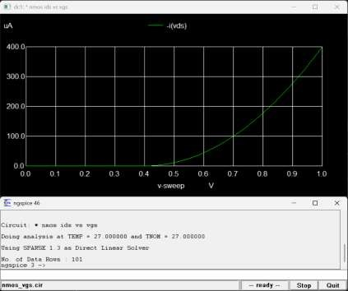

- ISD Vs. VSD Characteristics of PMOS for VSG = 0.5V: ISD, max = - 11 uA.
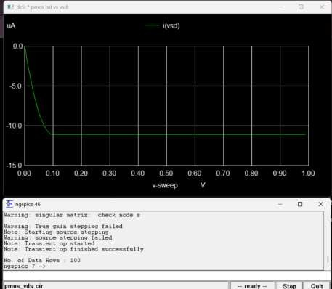

- ISD Vs. VSG Characteristics of PMOS for VSD = 1V:
Approx. Vth = 0.4 V
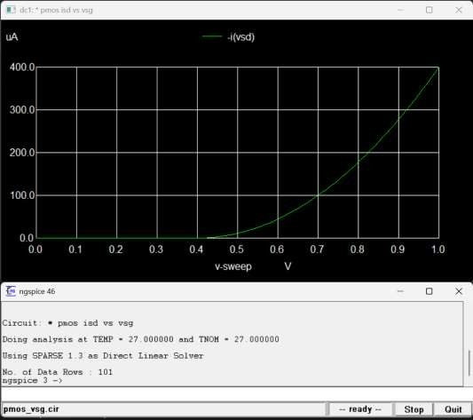

  - Conclusion: Comparative comments on your results from both transistors
The SPICE simulation successfully verified the characteristics of NMOS and PMOS. Both show linear and saturation regions, with approximately 0.4 V threshold voltage. NMOS and PMOS have similar characteristics but opposite current directions.

Name: Sudarshan Anil Chaudhari Roll No.: 06
G.R. No.: 12520111
Division: G

EXPERIMENT NO: 02
TITLE OF EXPERIMENT: Write SPICE model for CMOS inverter and perform transient and DC analysis.

  - Aim: - Write SPICE model for CMOS inverter and perform transient and DC analysis.
  - Software/Hardware: - Any SPICE tool like Winspice, NGspice etc.
  - SPICE code: (Copy paste your SPICE code here. Write your name and PRN No. in comments.) (Use L = 90 nm for both transistors, W = 0.5 um for NMOS and W = 1 um for PMOS. Use VDD = 1V)
    - CMOS Inverter - Transient and DC Analysis
    - Power supply VDD vdd 0 DC 1
    - Input signal for transient analysis VIN in 0 PULSE(0 1 0 1n 1n 5m 10m)
    - CMOS inverter
MP out in vdd vdd PMOS L=90n W=1u MN out in 0 0 NMOS L=90n W=0.5u
    - MOSFET models
.model NMOS NMOS (LEVEL=1 VTO=0.4 KP=200u)
.model PMOS PMOS (LEVEL=1 VTO=-0.4 KP=200u)
    - Transient analysis
.tran 0.01m 20m
.control
    - Transient analysis run
plot v(in) v(out)
    - DC analysis dc VIN 0 1 0.01
plot v(out) vs v(in)
.endc
.end

  - Simulation result screenshot: (Copy paste simulation result screenshots here.)
- Transient response:
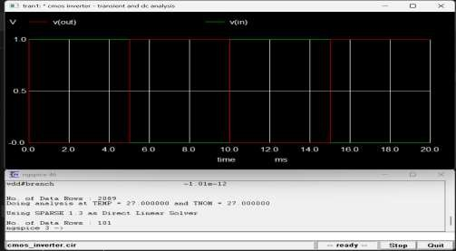

- Voltage transfer characteristics (DC response):
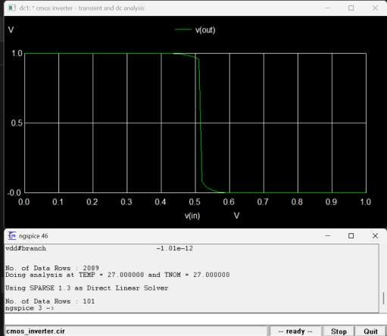

  - Conclusion: Comment on Switching Threshold Voltage of the Inverter (VM)
The CMOS inverter successfully performs voltage inversion. The switching threshold voltage 𝑉_{𝑀}is approximately 0.51 V, where 𝑉_{𝑖𝑛} ≈ 𝑉_{𝑜𝑢𝑡}.

Name: Sudarshan Anil Chaudhari Roll No.: 06
PRN No.: 12520111
Division: G

EXPERIMENT NO: 03
TITLE OF EXPERIMENT: To perform transient and DC analysis of CMOS Inverter using Cadence Virtuoso.

  - Aim: - To perform transient and DC analysis of CMOS Inverter using Cadence Virtuoso
  - Software/Hardware: - Cadence Virtuoso Schematic Editor, Spectre simulator, and gpdk090 technology library.
  - Specifications:

Technology: 90 nm Supply voltage: 1.0V
L = 100 nm for both transistors, W = 0.5 um for NMOS and W = 1 um for PMOS
  - Schematic: (Copy paste your schematic here. Write your name and Roll. No. in comments.)

- Circuit schematic:

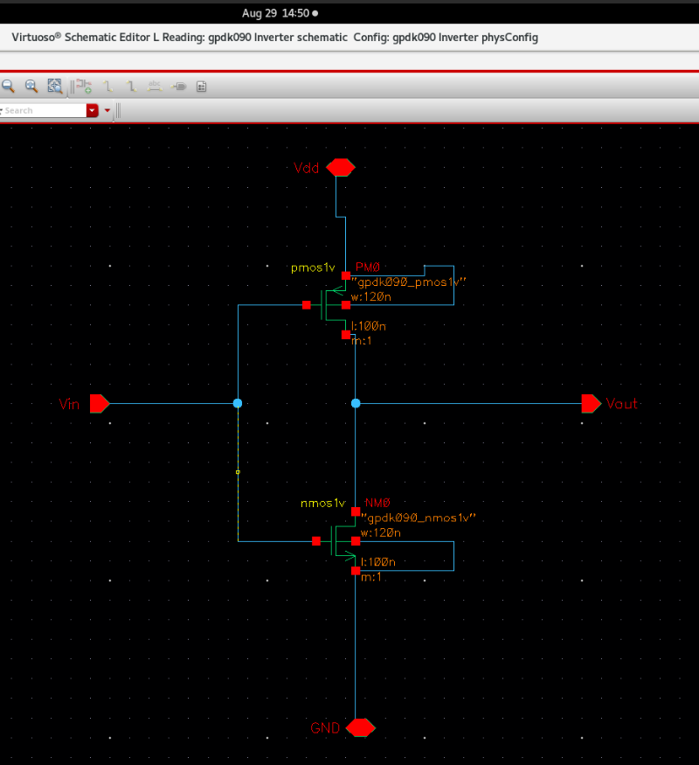

- Testbench schematic:
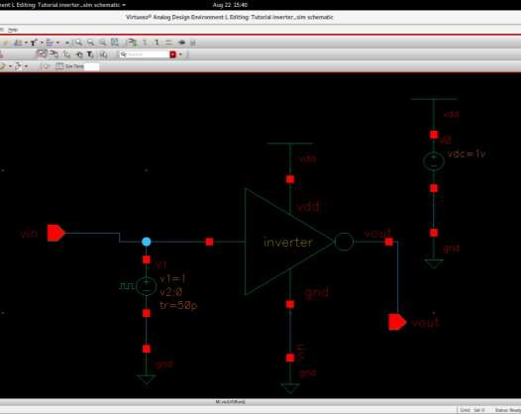

  - Simulation result screenshot: (Copy paste simulation result screenshots here.)
- Transient response:
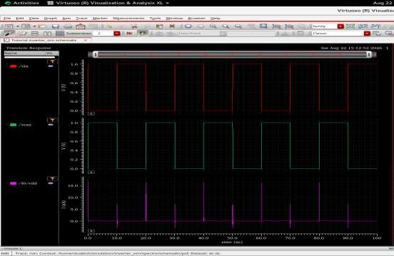

- Voltage transfer characteristics (DC response):

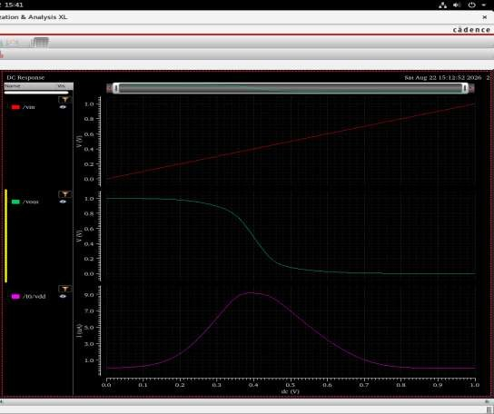
  - Observation Table:

Specification | Value
Output high-to-low time (t_{pdf}) (in ns) | 0.05 ns
Output low-to-high time (t_{pdr}) (in ns) | 0.05ns
Average power dissipation (in µW) | 1–2 µW

  - Conclusion:
The CMOS inverter was successfully designed and simulated using Cadence Virtuoso. The transient and DC responses were obtained, and the inverter showed proper voltage switching. The switching threshold voltage 𝑉_{𝑀}was found to be approximately 0.5 V.

Name: Sudarshan Anil Chaudhari Roll No.: 06
PRN No.: 12520111
Division: G

EXPERIMENT NO: 04
TITLE OF EXPERIMENT:Design of CMOS Inverter layout using Cadence Virtuoso

  - Aim: Design CMOS Inverter layout for the circuit designed in experiment number 3 using Cadence Virtuoso

  - Software: Cadence Virtuoso Layout Editor, Spectre simulator and gpdk090 technology library.

  - Layout Diagram screenshot:
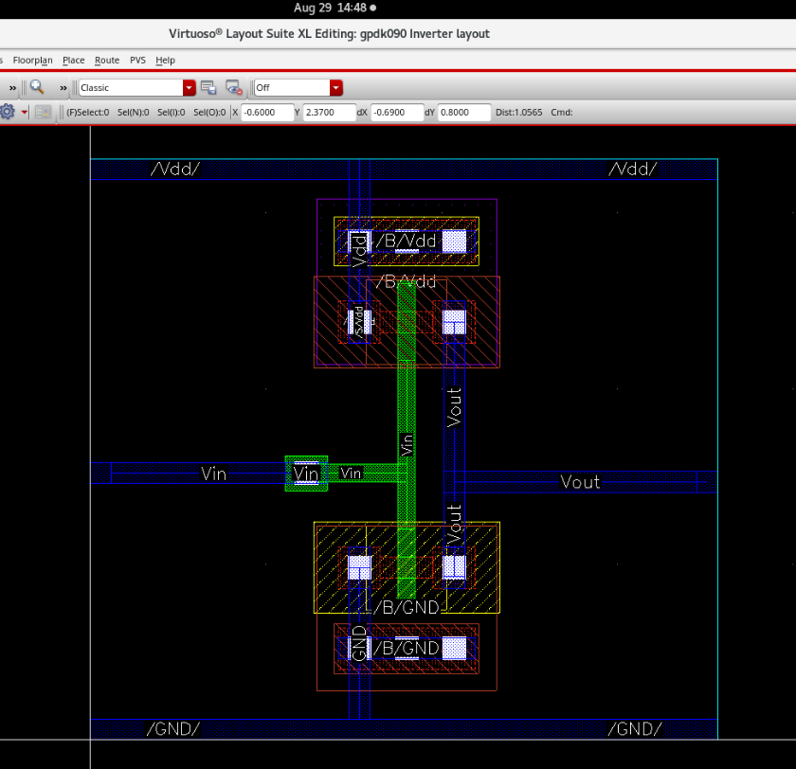

  - AV Extracted View screenshot:
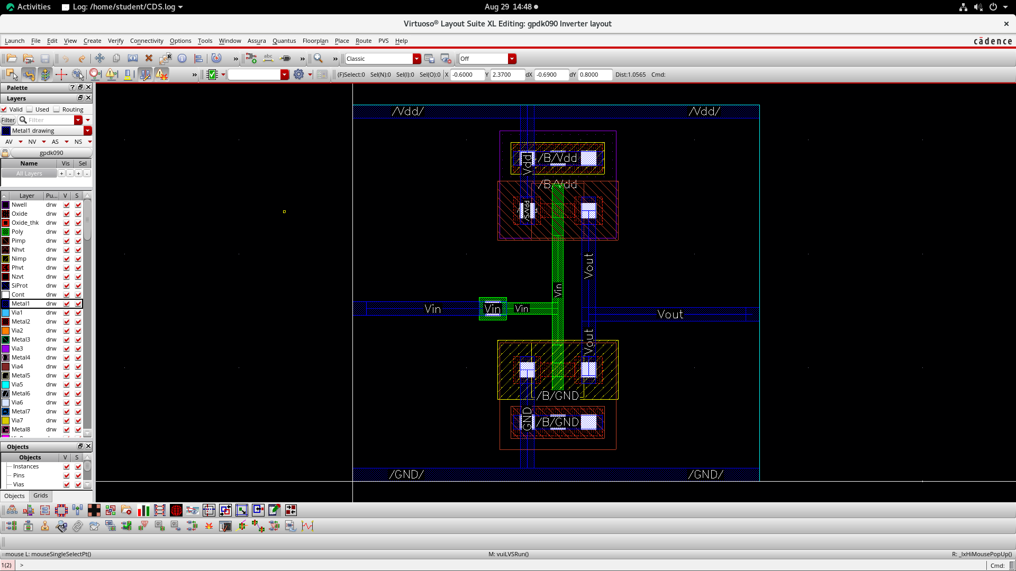

  - Observation:

Delay between pre-layout and post-layout simulated outputs = 0.02 ns

  - Conclusion:

The CMOS inverter layout was successfully designed using Cadence Virtuoso. The layout was verified using the extracted view and LVS, and the post-layout simulation confirmed proper inverter operation with a small delay due to parasitic effects.

Name: Sudarshan Anil Chaudhari Roll No.: 06
PRN No.: 12520111
Division: G

EXPERIMENT NO: 05
TITLE OF EXPERIMENT: To perform simulation and plot transient response of 2-input NAND Gate.

  - Aim: - To perform simulation and plot transient response of 2-input NAND Gate.

  - Software/Hardware: - Cadence Virtuoso Schematic Editor, Spectre simulator, gpdk090 technology library.

  - Specifications:

Technology: 90 nm Supply voltage: 1.0V
L = 100 nm for all transistors, W = 480 nm for all transistors
  - Schematic: (Copy paste your schematic here. Write your name and Roll. No. in comments.)
- NAND gate schematic:
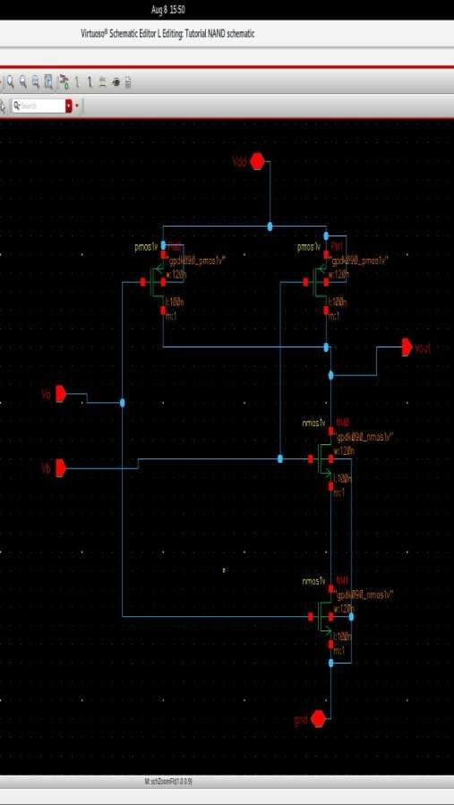

- NAND gate testbench:

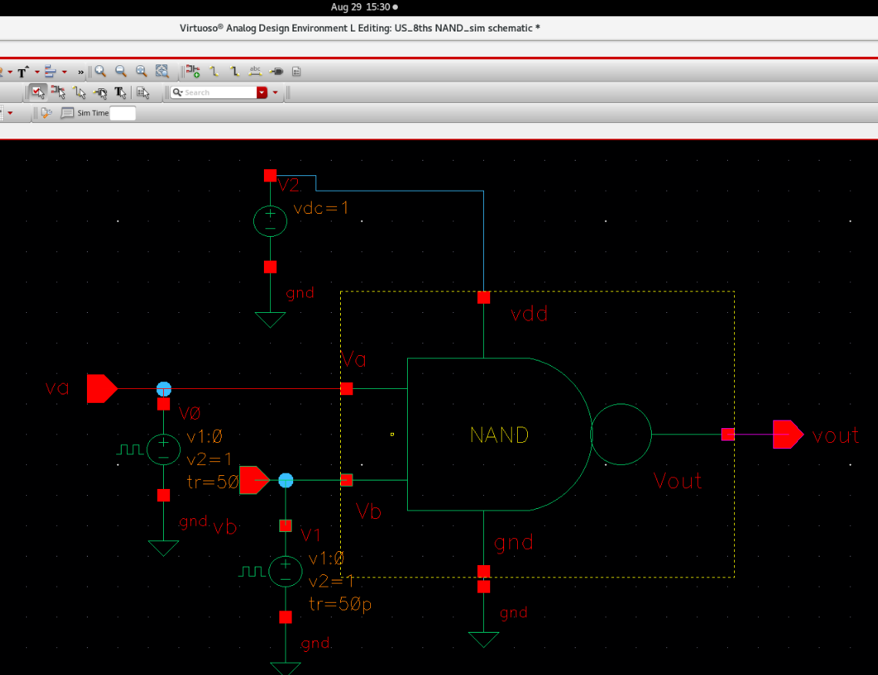
  - Simulation result screenshot: (Copy paste simulation result screenshots here.)
Transient response of NAND gate:
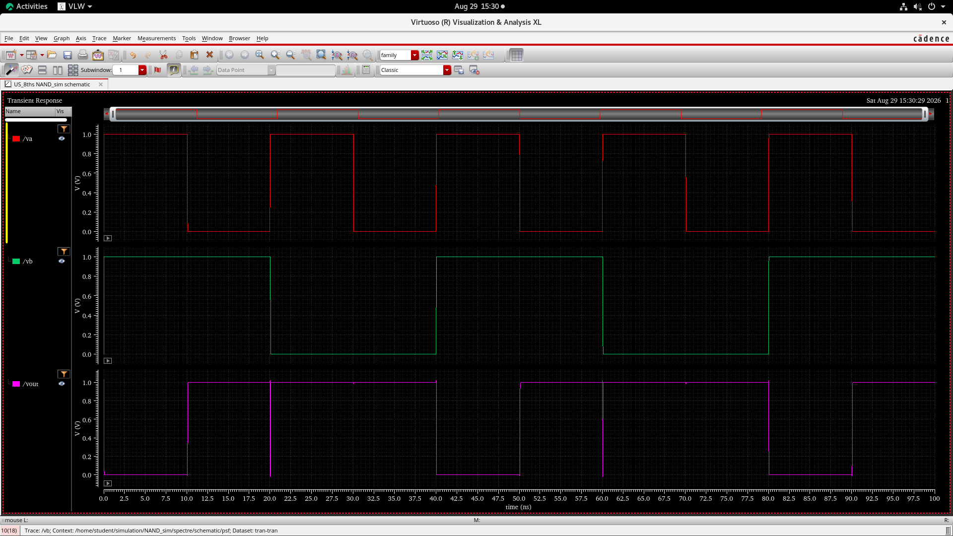

  - Observation Table for NAND gate:

Specification | Value
Input 1 to Output high-to-low time  (t_{pdf}) (in ns) | 0.1 ns
Input 1 to Output low-to-high time  (t_{pdr}) (in ns) | 0.1 ns
Input 2 to Output high-to-low time  (t_{pdf}) (in ns) | 0.1 ns
Input 2 to Output low-to-high time  (t_{pdr}) (in ns) | 0.1 ns
Average power dissipation (in µW) | 10 uW

  - Conclusion:
The 2-input CMOS NAND gate was successfully designed and simulated using Cadence Virtuoso. The transient response verified the NAND logic operation, where the output becomes LOW only when both inputs are HIGH. The gate showed proper switching with small propagation delay and power dissipation.

Name: Sudarshan Anil Chaudhari Roll No.: 06
PRN No.: 12520111
Division: G

EXPERIMENT NO: 06
TITLE OF EXPERIMENT: Design of CMOS 2-input NAND gate layout.

  - Aim: Design of CMOS 2-input NAND gate layout.

  - Software: Cadence Virtuoso Layout Editor, Spectre simulator, and gpdk090 technology library

  - Layout Diagrams of NAND gate:
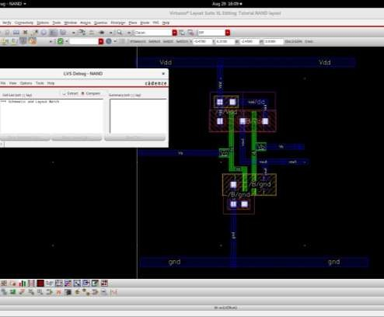

  - AV Extracted View of NAND gate:
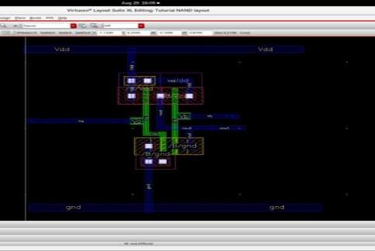

  - Conclusion:

The 2-input CMOS NAND gate layout was successfully designed and verified using Cadence Virtuoso. The layout showed correct connections for VDD, GND, inputs, and output, and the LVS verification passed successfully, confirming that the layout matches the schematic.

